Health Advisory Council
August 26th, 2025
8:00 AM – 9:00 AM

MEETING LOCATION: Virtual
Co-Chairs: Jean Loo Russo and DeAndrea Brazel

- Welcome & Introductions – Jean Loo Russo and DeAndrea Brazel
- Ice Breaker: Birthday Month and Favorite Bday Treat, Cake, Ice Cream, Pie

- Chamber Updates – Chris Thorne, CEO North SD Business Chamber

  - Upcoming Events

- Community Updates – DeAndrea Brazel/Guest Speaker Eva Matthews, CFO MaMa’s Kitchen
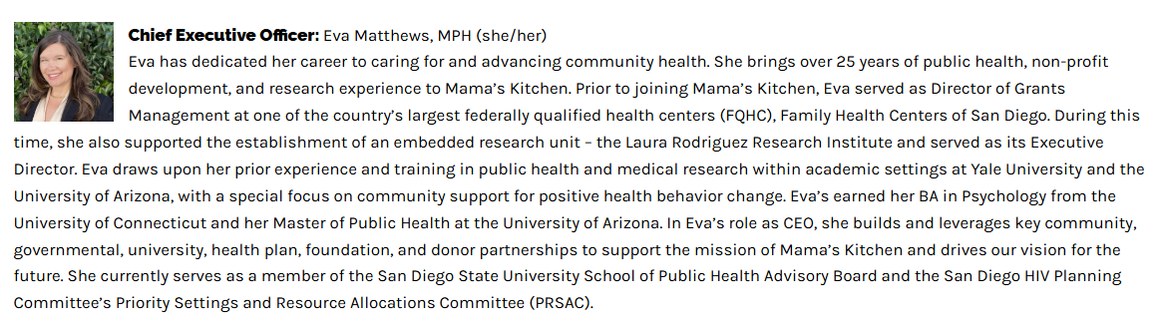

- Old Business – DeAndrea Brazel

  - Dates for In Person meetings: October 28th (Medicare Panel) and January 27th

- New Business – Jean Loo Russo and DeAndrea Brazel

  - Review of Legislative Principles for 2025-2026 Fiscal Year
  - Discuss Health Fair October Regional Connect) Palomar Health
Please solicit sponsors
Presenting: Elizabeth Hospice
Supporting Sponsors: ROWI Team and Parent Wellness Centers
Exhibitors: Chamber, True Care, TERI Campus of Life, A Place at Home, Unicare Hospice Inc., Stronger Together Community Services

- Chamber Council Member Updates – Jean Loo Russo
- Close Meeting – Jean Loo Russo

